Comparing Corrosion Performance of HydroLogic™/Optiform® to Carbon Steel and Galvanized Steel ERW Pipe

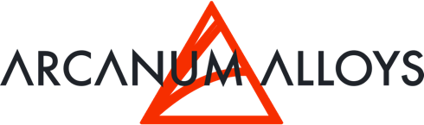
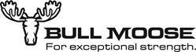

Adam G. Thomas Mark Abernathy
Director NPI & Marketing Manager of Field Applications
Arcanum Alloys Bull Moose Tube Company
4460 44th St. SE Ste F 1819 Clarkson Road
Kentwood, MI 49512 Chesterfield, MO 63017
(630) 715-4899 (800) 325-4467
www.arcanumalloys.com www.bullmoosetube.com

Comparing Corrosion Performance of HydroLogic™/Optiform® to Carbon Steel and Galvanized Steel ERW Pipe

Background
In fire-sprinkler system design and engineering, a C-Factor is assigned to piping to account for the impact of the pipe’s surface roughness on the flow of water through the system. For more information on this phenomenon, please see the paper entitled, “Spatially Optimized Diffusion Alloys in Fire Sprinkler Pipe Applications.” Corrosion, or a lack thereof, establishes the roughness of a pipe’s interior surface, which dictates the C-Factor of a piping material. Additionally, corrosion influences the propensity of a system to experience catastrophic clogging failure and can create leaks in a system over time. Accelerated-corrosion testing of materials is a commonly used method to simulate in a matter of weeks the amount of corrosion that would occur over several years or even decades.

Analysis of post-test materials and their corrosion products (resulting level of corrosion) allows the measurement of several useful factors impacting sprinkler-pipe performance. Corrosion- product roughness can be measured to estimate C-Factor flow properties of the pipe. Corrosion- product volume can be used to estimate the potential for a material to clog fire-sprinkler heads. Cross-sectional inspection of weld seams can be used to understand a material’s potential to experience knife-line corrosion along the weld seam and form leaks while in service.

Method
To perform accelerated-corrosion testing, HydroLogic™ ERW tubing was produced by Bull Moose Tube Company using Arcanum Alloys’ Optiform® in 0.090” gauge. This sample of HydroLogic™ pipe was sent to Arcanum Alloys, along with samples of conventional carbon-steel and galvanized-steel ERW tubing for accelerated-corrosion testing. Each type of pipe was sectioned according to Exhibit 1, so that during salt-spray and condensing-humidity testing, initial fog trajectory would be perpendicular to the weld seam. This approach was used to simulate accelerated corrosion on the traditionally highest-risk site in a worst-case scenario.

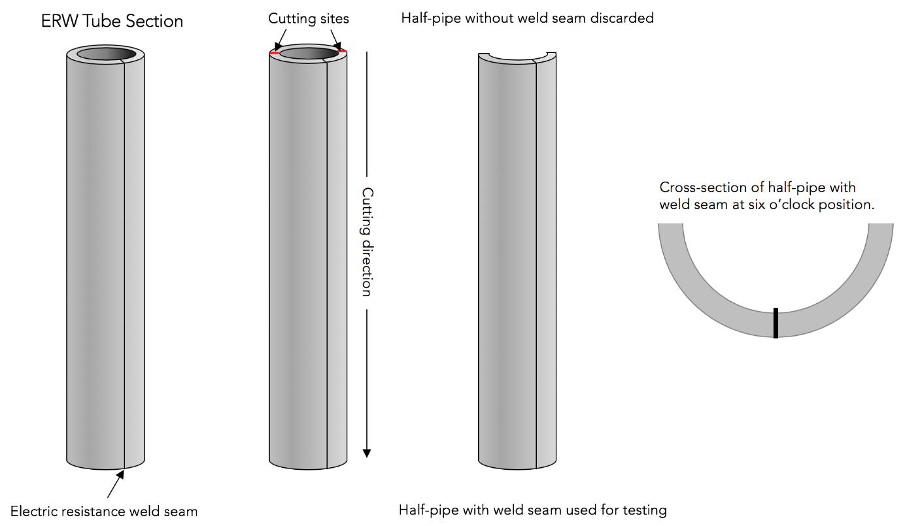
Exhibit 1 – Tube section preparation for ASTM B117 salt-spray testing

To observe effects of corrosion on the pipe walls and weld seam, both salt-fog testing (ASTM B117) and hot-condensing-humidity testing (a modified ASTM B117) were performed for 1,000 hours to induce corrosion of the pipe diameter. Note that salt-fog testing is an extremely aggressive test. There has never been strong agreement in the scientific community on the interpretation of the data derived from this test, nor on the impact these data have on real-world applications. For example, no strong correlation between the ASTM B117 time to failure and service life has ever been established. Instead, given its propensity to quickly generate corrosion product often seen in-field, it is used as a screening test. This is how this test was used in this study. Alternatively, hot-condensing-humidity testing provides a more realistic simulation of the real world. Compared to ASTM B117, where temperature is held at 35C (95°F), this test was carried out at 50C (122°F) to increase the corrosion rate. Additionally, deionized water was used in the test media instead of 5% salt, which is much closer to what would be seen in field. However, the lower chlorine content makes it take longer to generate corrosion products.

The hot-condensing-humidity test used deionized-water fog that was produced at 2-cm³/hr. per 1-cm² surface area, in a closed chamber at 50°C (122°F). Arcanum Alloys employed a Hastest HCST-6NL environmental chamber for this testing.

Salt-spray testing using ASTM method B117 utilizes a 5%wt. salt (sodium chloride) fog that is produced at 2-cm³/hr. per 1-cm² surface area, in a closed chamber at 35°C (95°F). Arcanum Alloys used a Q-Fog CCT1100 manufactured by Q-Lab to perform this testing.

Sample lengths of pipe had their cut edges taped, so that corrosion only occurred in a direction that pipe would typically experience in-field; i.e., from the ID towards the OD. The entire 18” sample of each material type was placed into salt spray at 25° from the vertical.

Each material was exposed for 200, 500, and 1,000 hours in both testing environments. Afterwards, several types of measurements were made. The cross-sectional thickness of the wall was measured to calculate volume of oxidation product created. The roughness of the oxidation product was measured using a stylus profilometer to estimate C-Factor ahead of hydraulic testing. Additionally, the erosion of material at the weld seam was measured by subtracting the original cross-sectional wall thickness at the weld seam by the thickness at a given duration and material. To make cross-sectional measurements, coupons were cut so that the weld seam was positioned in the middle, and the coupon was placed into epoxy so that the cross-section could be polished for observation under a microscope.

RESULTS
The graphic in Exhibit 2 demonstrates the difference in non-corrosion-resistant surface area per type of pipe, and the resulting corrosion-product volume as measured by wall-thickness loss multiplied by the ratio of oxidation-product density over metal density. Despite white zinc hydroxide/carbonate (white rust) formation almost immediately in salt spray, the galvanized material did not lose as much wall thickness as the carbon steel material. However, both carbon steel and galvanized steel produce a corrosion product at the entire inner diameter surface. Optiform, on the other hand, is a spatially optimized, diffusion-alloyed surface that has been enriched with Chromium to provide corrosion resistance. As such, the only area where corrosion can occur is at the ERW seam.

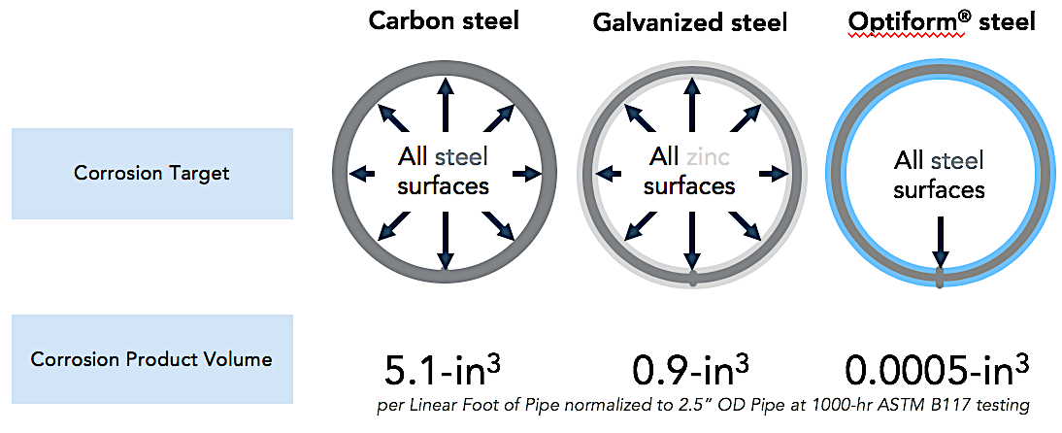
Exhibit 2 – Corrosion target and product volume calculated by wall-thickness reduction

Since corrosion only occurs at the weld seam of Optiform tubes, the available metal to participate in corrosion-product formation is a minute fraction of what is available in the carbon or galvanized products. This effect is more pronounced as pipe diameter increases. While larger- diameter pipes can be specified to account for pressure drop, this also creates more surface area per linear foot of pipe, which in turn creates the potential for more corrosion product, thus increasing the likelihood of catastrophic sprinkler head failure by clogging. Alternatively, a higher-powered pump can be used to overcome pressure drop, but this is typically a last resort due to a high cost-to-performance ratio.

Hydraulic flow is not only determined by the radius of the tube, but also by the surface roughness. Oxidation products of both carbon steel and galvanized steel are substantially rougher than their metal counterparts. As such, the C-Factor of each material is altered to account for inherent corrosion inside the sprinkler pipe. To estimate this C-Factor adjustment, Arcanum utilized a Starrett SR300 stylus profilometer on the surface of each pipe after 1,000-hr salt-spray exposure. Giving an average roughness value (Ra) of approximately 350 and 160 microinches respectively, the carbon-steel and galvanized-steel surfaces increased roughly three and two times their respective original surface roughness. The surface roughness measured on Optiform was approximately 75-microinches, representing insignificant change. Exhibit 3 illustrates roughness before and after salt-spray testing. The assignment of a C-Factor was carried out by Missouri University of Science and Technology in a separate test and will be the subject of a later paper.

The condensing-humidity testing induced corrosion on both the galvanized-steel and carbon-steel pipes, as well as some corrosion at the weld seam of the Optiform pipe, but corrosion was only superficial in all cases out to 1,000 hours. After 1,000 hours of salt spray, galvanized-steel and carbon-steel pipe showed heavy corrosion spread across the inner diameter of the pipe, whereas the Optiform pipe sample only exhibited corrosion at the weld seam. While some mass loss was observed on all samples, none of the weld seams perforated.

Lower corrosion product roughness translates into higher C-Factor
Exhibit 3 – Carbon steel initially has a C-Factor of 150, but since corrosion occurs with extended service, it is often given a C-Factor of 100 to acknowledge reduced flow. It is estimated, based on surface roughness before and after 1,000-hr ASTM B117 exposure, that Optiform will retain a high C-Factor.

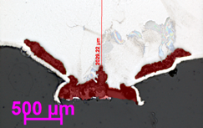
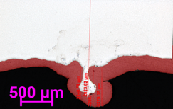
b.
a.

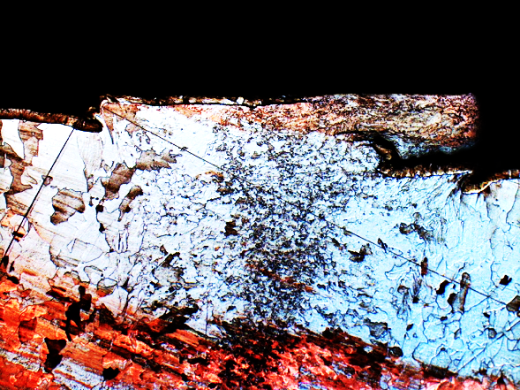
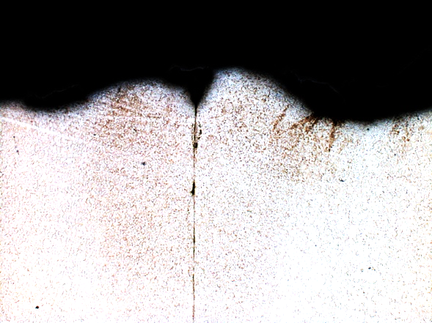
d.
c.

Exhibit 4 – a.) carbon steel pipe weld seam after 1,000 hours in salt spray, where red-shaded area marks original wall cross-section lost as corrosion product. b.) Optiform steel pipe weld seam after 1,000-hours in salt spray, where red-shaded area marks original wall cross-section lost as corrosion product. c.) carbon steel after 1,000-hours in hot condensing humidity, showing no cross-section loss. d.) Optiform steel after 1,000-hours in hot condensing humidity, showing no cross-section loss.

CONCLUSION
Three key material properties are considered when specifying sprinkler pipe for fire suppression: the propensity of corrosion product to clog sprinkler heads and cause them to fail, the pipe material’s C-factor for hydraulic flow consideration, and weld-seam corrosion susceptibility that can cause leaking. In these three key areas, Optiform compares favorably against traditional materials. Since more than 99 percent of an Optiform pipe’s internal surface area is ferritic stainless, corrosion product generated is orders of magnitude lower than ERW pipe made from carbon and galvanized steels. In C-Factor correction, where galvanized- and carbon-steel pipe experience drastic reduction of flow over time, it is expected that Optiform will outperform both materials substantially. While cross-sectional wall-thickness loss was observed in all samples, no material showed perforation, even at 1,000 hours of salt-fog testing. The next paper in this series will cover the assignment of a C-Factor for ERW pipe made from Optiform steel.

